Test Agent Construction Tool
Documentation
Dennis Geller
Preliminary Version February 27, 2008

The Test Agent Construction Tool (TACT) is a small software unit that can be used as a testing tool. The intent was for the tool to be useful for black box testing and regression testing by Q/A, assuming that developers will do white box testing. The TACT also serves as a simple example of a DDD agent (although it does not work within the Agent API guidelines.)

Overview:
The function of the tool is to allow a tester to frame a command (request) as might be generated by the client, and to monitor the return event from the server. (Any events from any components could be monitored, but the client/server interactions are the ones that the tool was designed to support.

As of this writing, the tool has one function. The document will discuss how to add additional functions – adding functions is probably the work of a developer.

Here is a picture of the screen

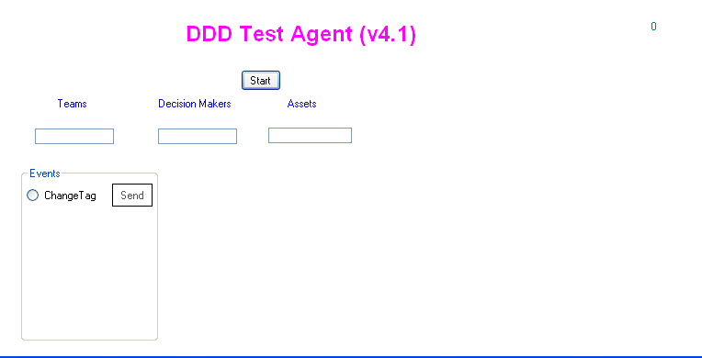

Along the top are list boxes which will contain lists of the teams, DMs and Assets known in a scenario. The left hand column contains the functions to be tested. Next to each function (there’s only one in this picture) would go a set of text boxes for specifying additional data for the command. When a radio button is selected, appropriate fields are enabled, disables, made visible or invisible. Thus, at a later stage the screen might look like this
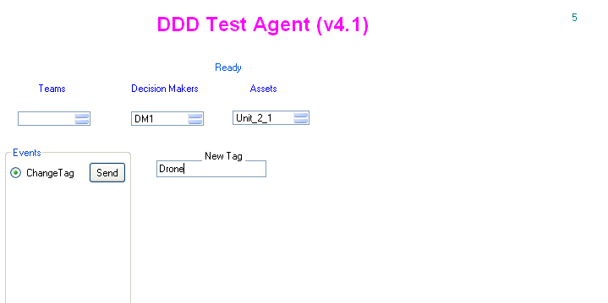
Where the list boxes for Decision Maker and assets, filled with the list of objects during server initialization, have been enabled and a text box for the tester to enter a tag text has been made visible. The result of sending the vent so specified to the server is a message box showing the returned fields:
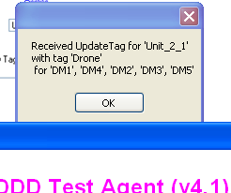

Operation
A significant complicating factor in the use of TACT involves sequencing. TACT must be running before the DDD server is started. In a DDD experiment, when a new client joins, the ViewPro sends it all the information it needs. However, this may not contain all the information needed by TACT. Therefore, TACT gets its initialization data (lists of teams, etc.) directly from the initial load of data from the server to the simulator.

Therefore, the proper way to begin a test with TACT is to follow these steps
- Launch TACT
- Press the Start button on TACT
- Launch the DDD Server
- Press the Start Server button
- 5. Verify that TACT has picked up data for its various list boxes; since fields are disabled until a particular testing event is chosen, such verification may need to be indirect – by observing, for example, that list boxes have developed scroll bars.
- Start the simulation
- Use TACT freely

Adding a test
We will build in a test of the TransferObjectRequest. This is sent by a DM from a client to request that a particular asset be transferred from its current owner to a different owner. If the request is approved by the controller, a TransferObject command is sent to the client; if not, a system message is sent.

We will first build in a capability to field System messages with TACT. The description of a SystemMessage is
<EventType Name="SystemMessage" Replay="false" SimCoreSubscribe="false">
<Description>
Sent by the SimCore or Controller to report a message to a client GUI or agent.
</Description>
<Parameter Name="PlayerID" DataType="StringType">
The decision maker the message is being sent to.
</Parameter>
<Parameter Name="Message" DataType="StringType">
The content of the message.
</Parameter>
<Parameter Name="TextColor" DataType="IntegerType">
The color that the message should be displayed as.
</Parameter>
<Parameter Name="DisplayStyle" DataType="StringType">
Use "DEFAULT" for whatever the client considers the default, "POP" to request a popup alert.
</Parameter>
</EventType>

Reception of a SystemMessage happens in the EventListener. EventListener need only extract the fields and pop up a message. This fits into a switch in EventListener and is quite straightforward:
case "SystemMessage":
string msgRecipient = ((StringValue)e["PlayerID"]).value;
string msgSystemMessage = ((StringValue)e["Message"]).value;
string msgColor =
((IntegerValue)e["TextColor"]).value.ToString();
string msgStyle = ((StringValue)e["DisplayStyle"]).value;
string msgMessage="Received SystemMessage for '"+msgRecipient+"' with color '"
+msgColor+"' and style '" +msgStyle+"'\n'"+msgSystemMessage+"'";
MessageBox.Show(msgMessage);
break;

The TransferRequest must be generated with TACT. There re few steps involved:
- Add a radio button; also, since transfer occurs between DMs, also add a second list box. The radio button begins unchecked. The list box begins empty, disabled and invisible. Also, add a Send button. Also, add a label for the list box, which will also be empty and invisible. All of this is done within the Form1 code. All entry fields also have a Flat Flatstyle
- Add an event handler for the radio button; the event is CheckChanged; if the value of checked is false, reset all the fields relating to this command to their original disables position; if true, enable and fill in as needed.
- Add a click handler for the Send button (btnTransfer). After verifying that the inputs are selected, this will generate the Transfer request and send it.
- You might want to do some white box testing here
- Add code to EventListener to display any events you want to .capture.
case "TransferObject":
string xferReceiver = ((StringValue)e["UserID"]).value;
string xferDonor = ((StringValue)e["DonorUserID"]).value;
string xferObject = ((StringValue)e["ObjectID"]).value;
string xferMessage = "Object '" + xferObject + "' transferred from '" + xferDonor + "' to '" + xferReceiver + '"';
MessageBox.Show(xferMessage);
break;

Reminders, cautions and futures
Reminders
- The order to start things up is
- Press start button on TACT
- Start server
- Start simulation
- TACT itself is not a DM.
- At the beginning we noted that TACT handled only change tag requesst. Now that you have read this it also handles transfer requests.
Cautions
- If there are any events in the scenario you are using, and you have displays for those event types, you will see notice of those events that you did not instigate from TACT as well as those you do.

- In particular, TACT will trap and display all system messages

Futures
- TACT subscribes to all events. The reason is that some system messages are directed to particular DMs. You would want to see them no matter whom they were addressed to, since they might be the only tangible result of the command you instigate. In some cases a tester might want to monitor the messages intended for one particular DM. This would require modest changes to the simulation event distributor.
- TACT monitors the creation of assets but not their revelation. Hence, you might choose to send a message about an asset that has not been revealed. This will make the server unhappy Better would be to disallow choosing of unrevealed assets for any command that requires revealed assets. (“Reveal” is one that doesn’t.)

